Name:
Course:
Professor:
Date:
Lighting systems part 1

Letter | Terms
d | Luminous intensity
f | Luminous flux
a | Illumination
g | Efficacy or luminous efficacy
e | Glare
b | Luminaire
- Illumination level – bright
Color – object
Glare – discomfort
Intensity – illuminated
Standard industry illumination values – characteristics
Lux levels – task

Type | Direct | Indirect | Semi-direct | Semi-indirect | General diffuser
Description | E | D | A | B | C
Picture | 5 | 4 | 1 | 2 | 3
- 1- flame or explosive proof housing
2- increased Ex e safety
3- metallic holder
4- seal to prevent ingress of liquid, gas, or dust
- a). GLS (general lighting system): Operation - when an electric current is passed from the source through the bayonet caps or the Edison screw fittings to the tungsten filament, the filament glows white hot and becomes a source of light.
Efficacy – 15-35 lumens/watt
Factors affecting lifespan – more current needed to maintain the temperature of the filament, voltage rating of the lamp, heavy vibration, ventilation, variation of supply voltage, and vaporization of the filament.
b). Halogen: Construction – a tungsten wire wound in coils is placed inside a glass envelop, which is filled with a halogen gas and an inert gas. Leads of the tungsten wire are connected to bayonet caps or Edison screw fittings.
Color output – similar to sunlight.
Factors affecting lifespan – degradation of the quartz glass, temperature gradient from the filament to the glass, blackening of the inner walls of the glass.
- a). push and twist
b). 22mm
c). terminals
d). left
e). threaded
f). locating lugs
g). pin

Lamp type | Voltage range | Auxiliary equipment | Installation requirements
Extra low voltage | 12V | Control equipment | May require installation of heat shield in certain circumstances. Auxiliary equipment may need to be installed above thermal insulation. Must be installed away from timber framing.
Low voltage | 0.6V – 11.5V | None | Must not be extended through a wall, they must be installed high enough to avoid short circuiting, must comply with the requirements of locations, the isolating power supply must not exceed 30V
- a). electric arc
b). gas
c). halides
d). sports facilities
e). lighting
f). outdoor
g). discharge
h). vaporized
i). factories
j). sodium
k). retail
l). high
m). electrode
n). mercury
- safety precautions for working on high voltage lighting
- check phase rotation prior to working on high voltage light fittings
- isolate high voltage lighting fittings prior to carrying out wok
- high voltages might be present when lamp is starting or restarting
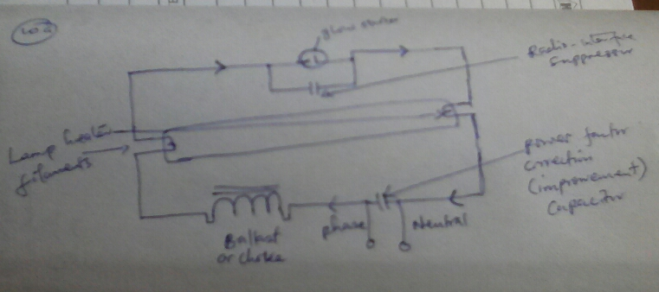
- always use test equipment rated for high voltages the equipment operates
- a).

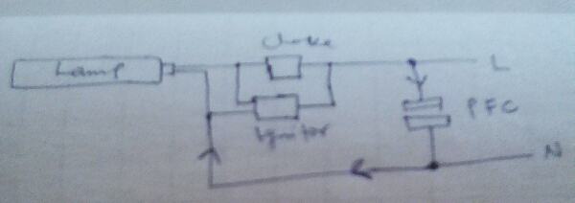
b). starter, conductor, terminals, arc, lamp, breaks, voltage, filaments, drops, limits.
c).

d). ignitor, pulses, main, starting, halide, blue, increases.
- Stationary, cannot, moving rapidly, not moving, safety, two lamps, different phases, capacitor, phase lag, amplifier, alternating current, direct current.
- Light, heat, multiple, desired, color, friction, failure, covered, flammable, savings.
- The correct operating voltage, has sufficient cooling/ spacing from flammable materials, the desired characteristics to match the task, complies with current legislation and standards.
- Temperature, brightness, 4.7, sign, recessed, see.
- CA-80, CA-135, IC, IC-F.

